Task 1

1.
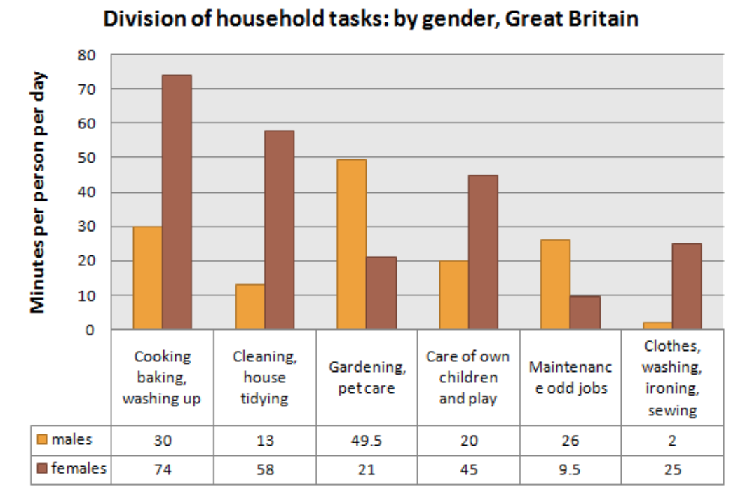

Type your answer below.
At least 150 words

2. 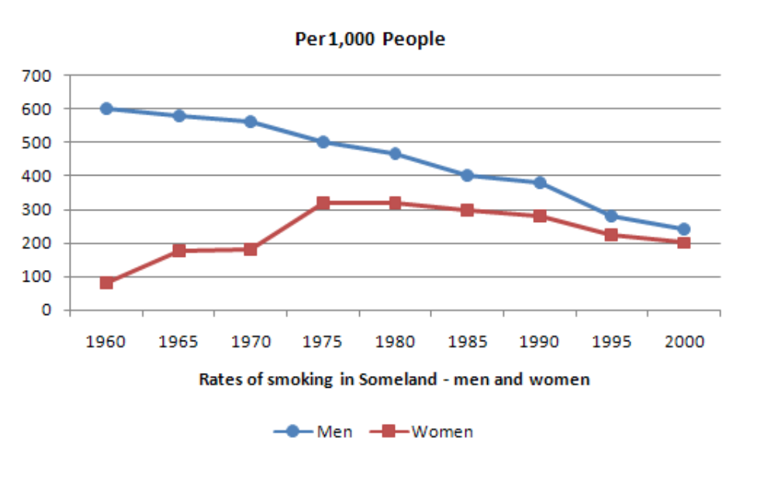

Type your answer below.
At least 150 words

3.
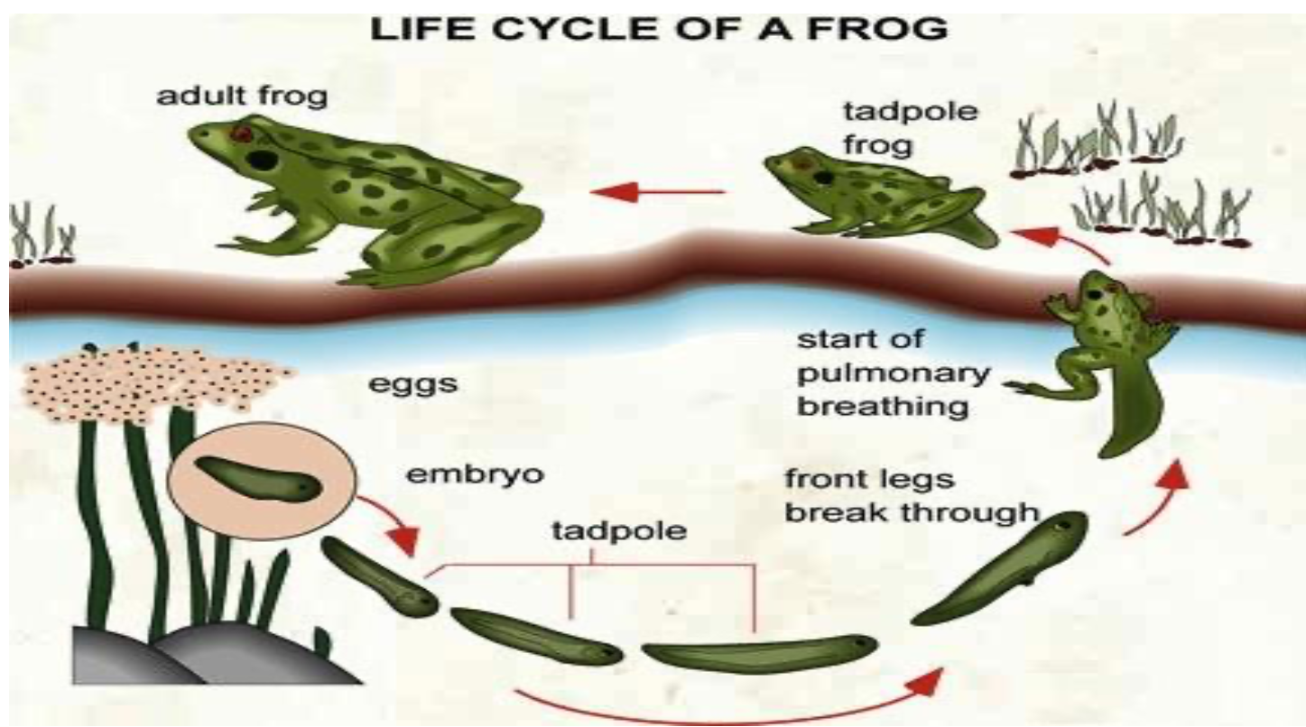

Type your answer below.
At least 150 words

4. 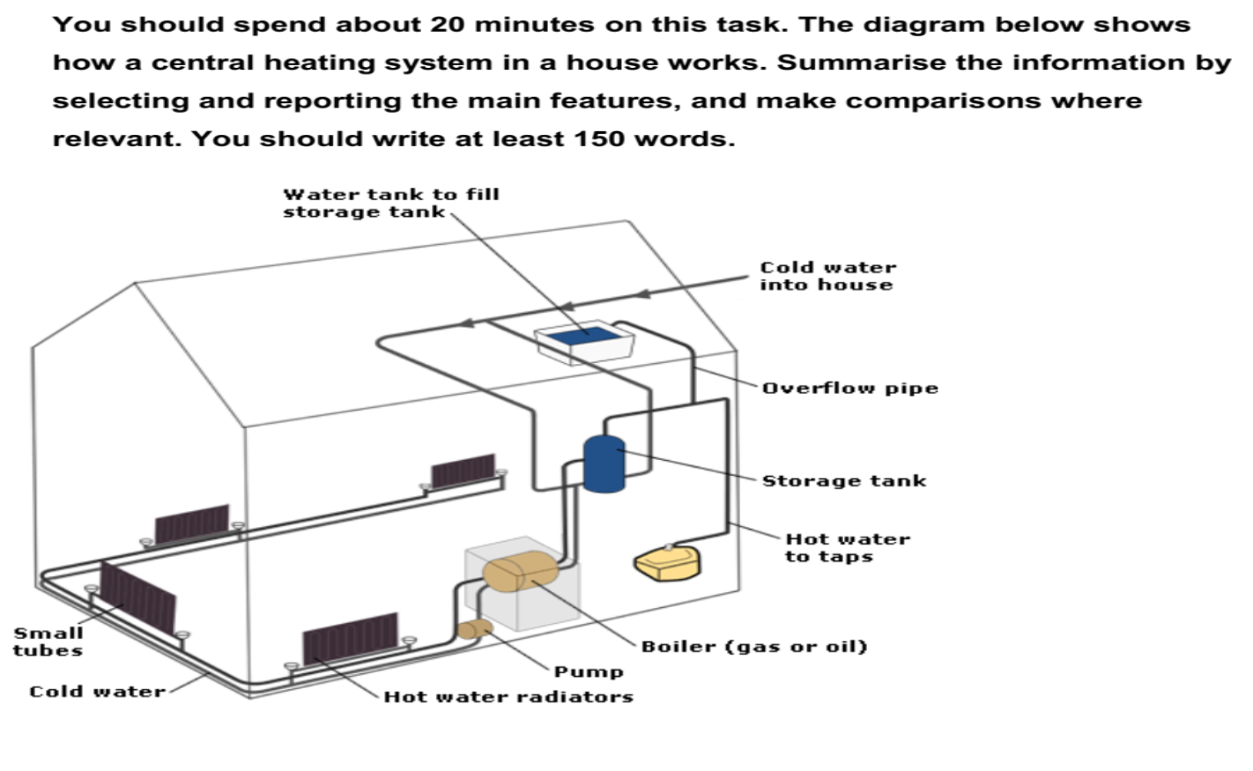
Type your answer below.
At least 150 words

5. 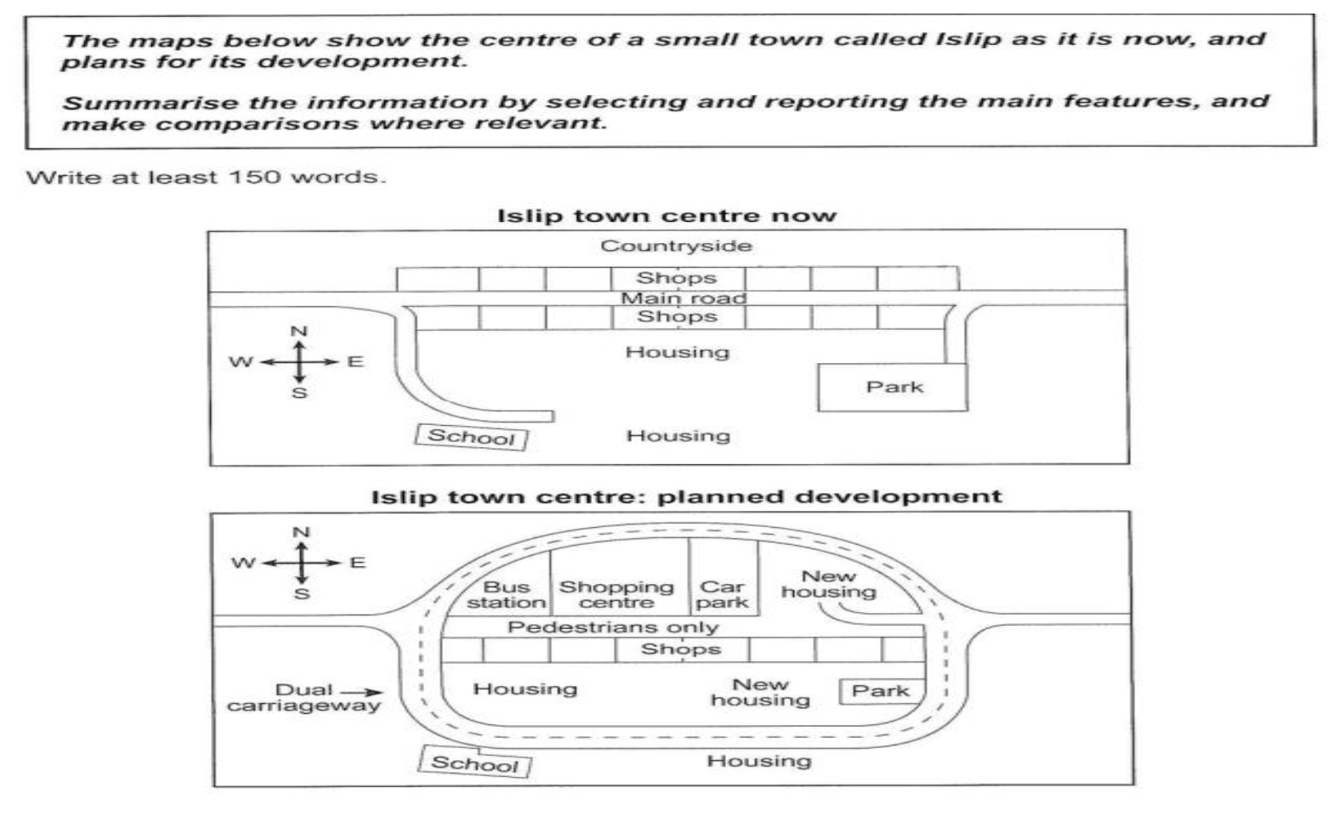
Type your answer below.
At least 150 words

6. 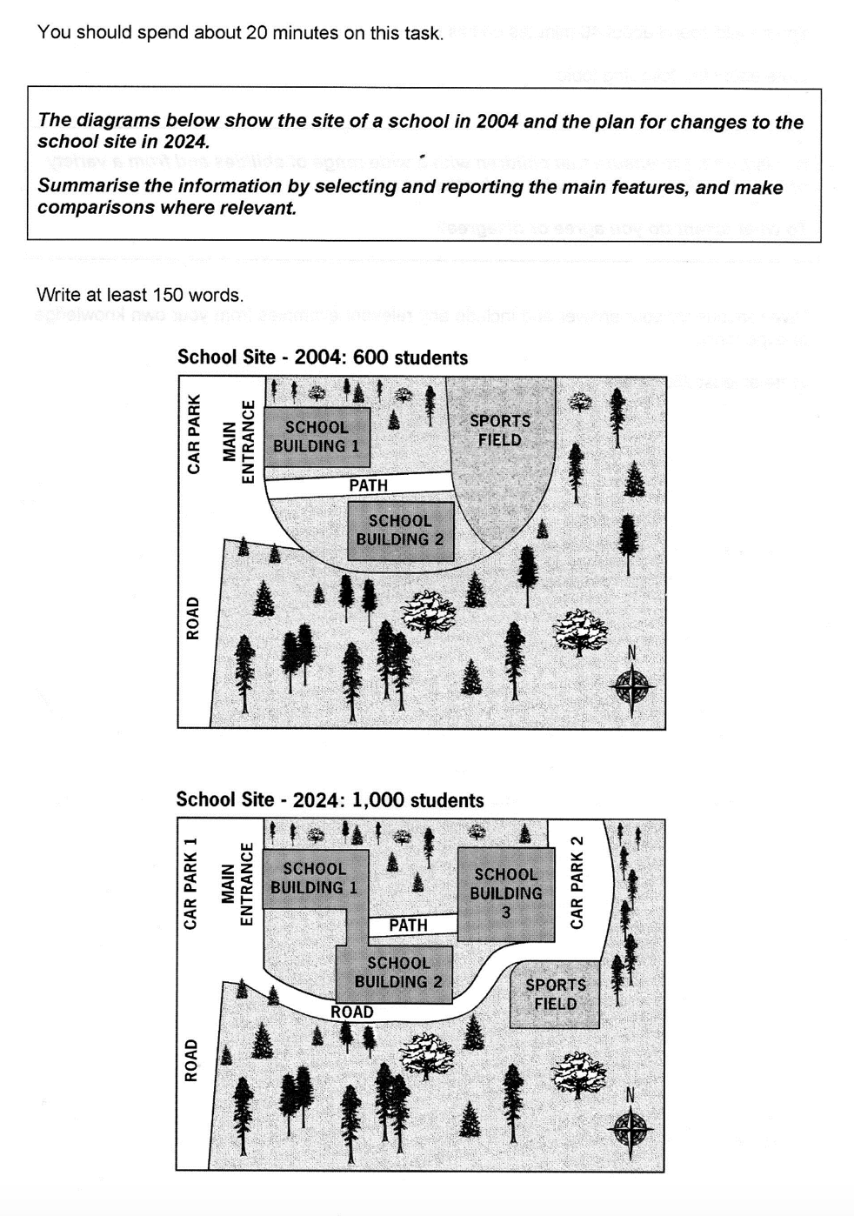

Type your answer below.
At least 150 words

7. 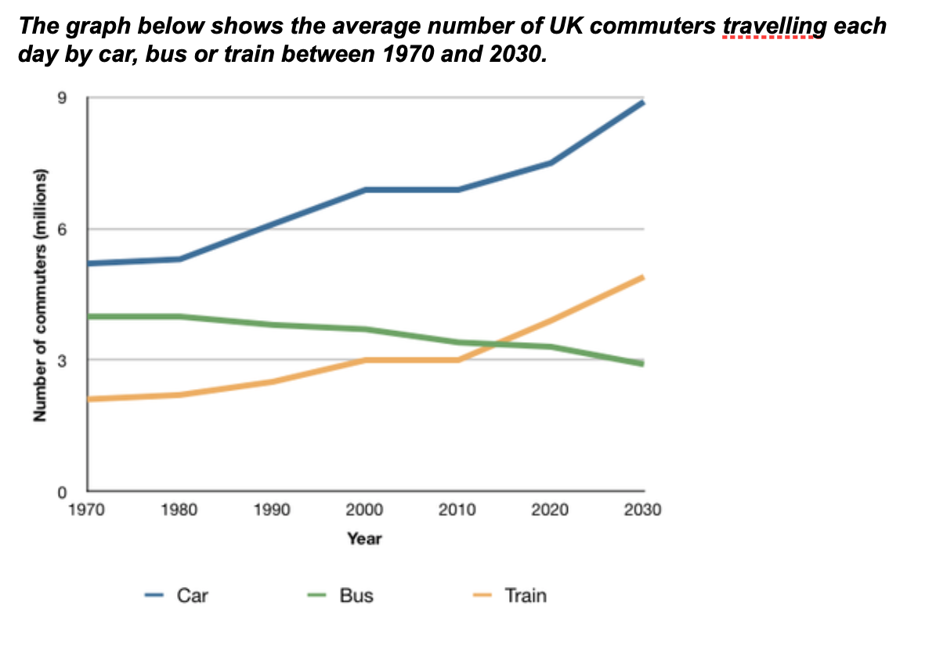
Type your answer below.
At least 150 words

8.
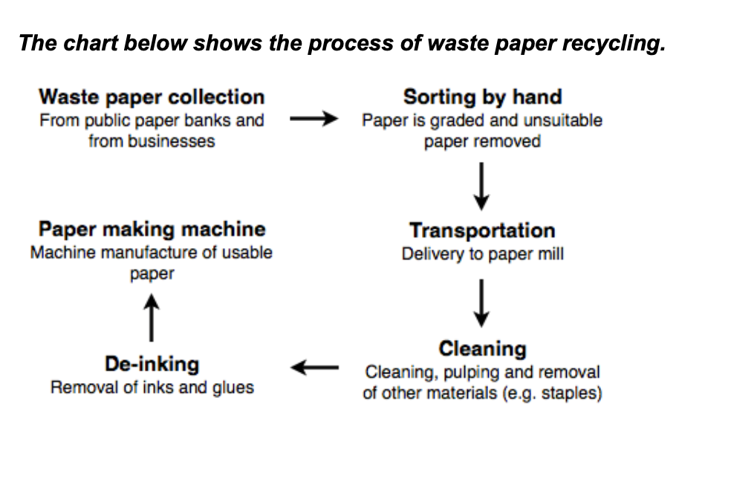

Type your answer below.
At least 150 words

9. 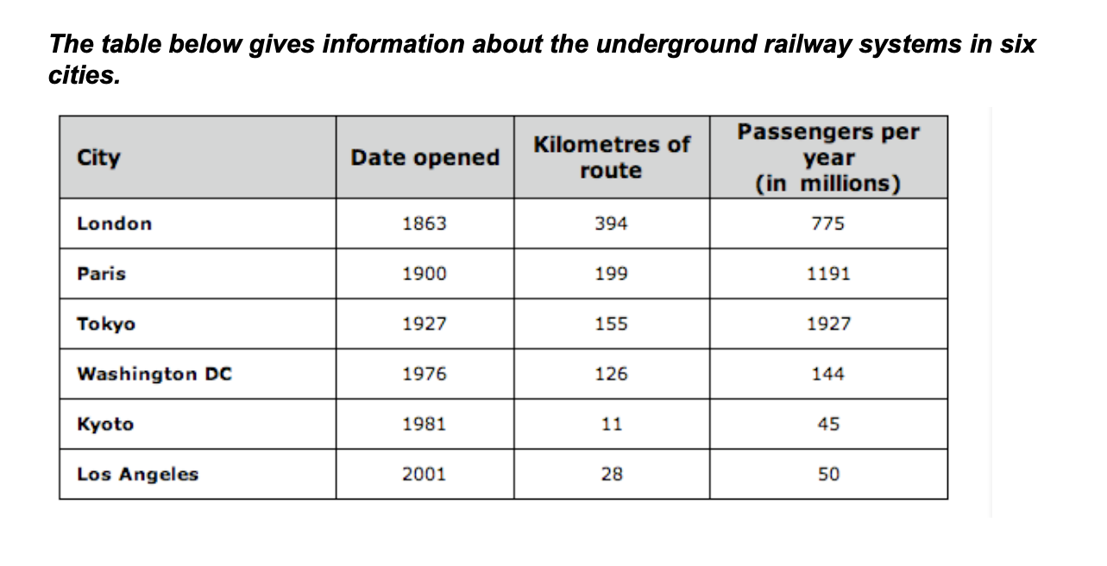
Type your answer below.
At least 150 words

10.
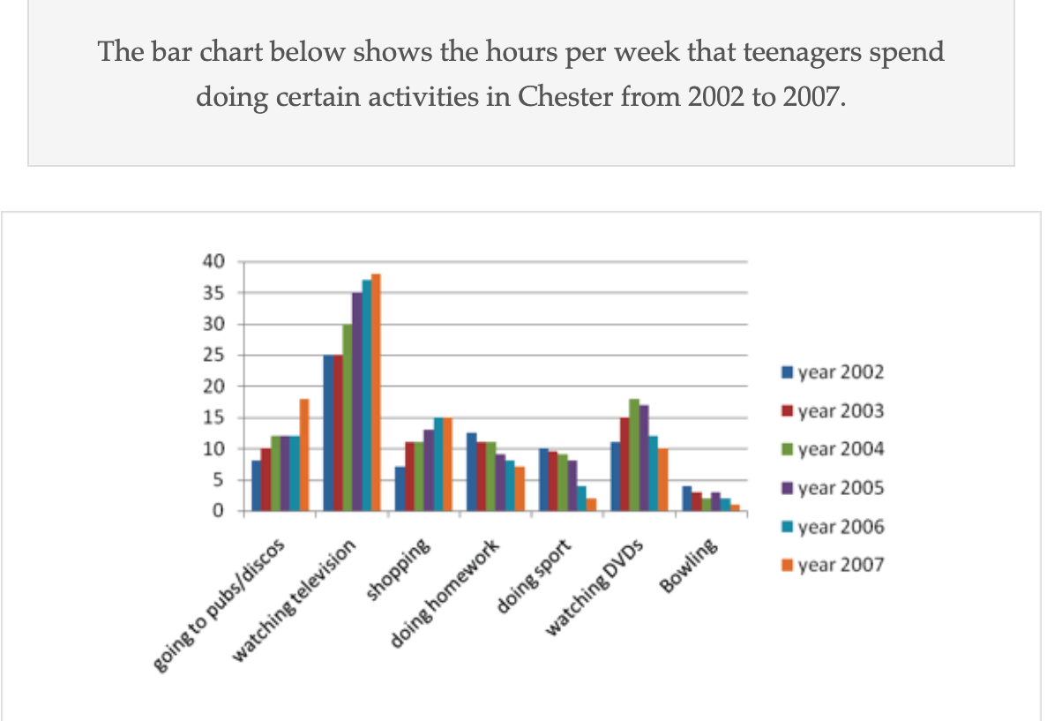
Type your answer below.
At least 150 words

11. 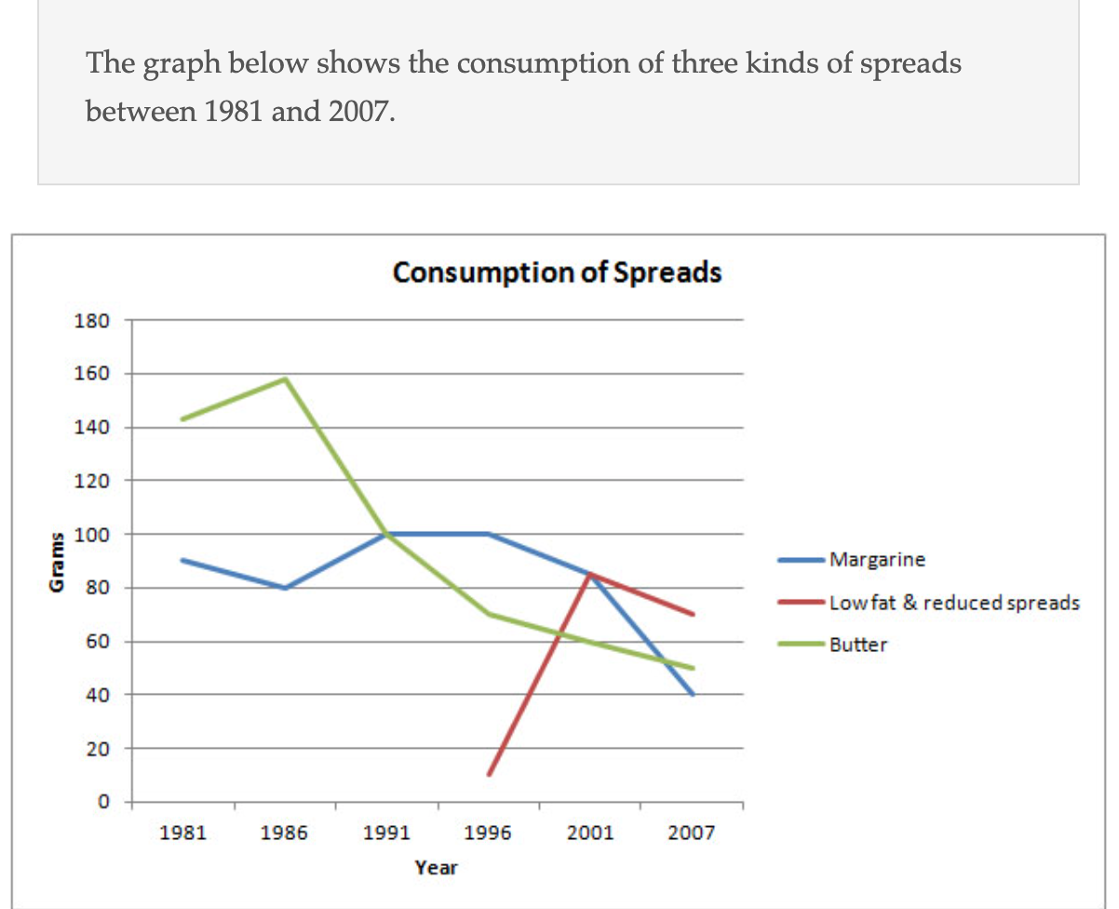

Type your answer below.
At least 150 words

12. 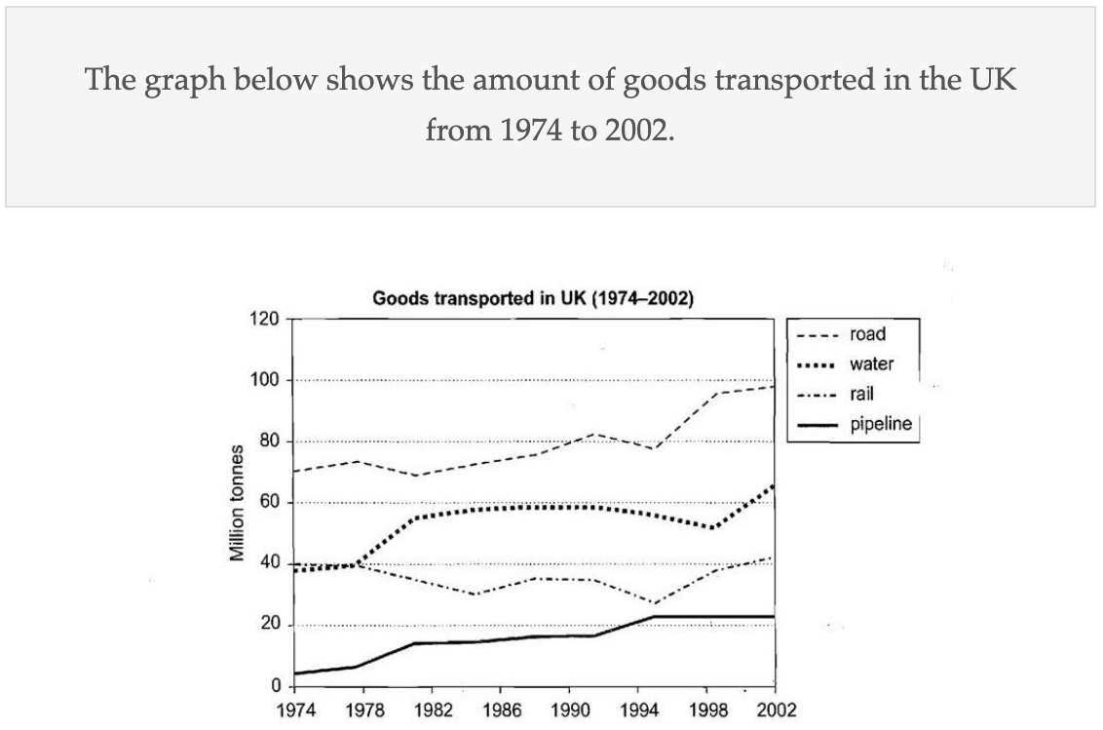
Type your answer below.
At least 150 words

13. 
Type your answer below.
At least 150 words

14. 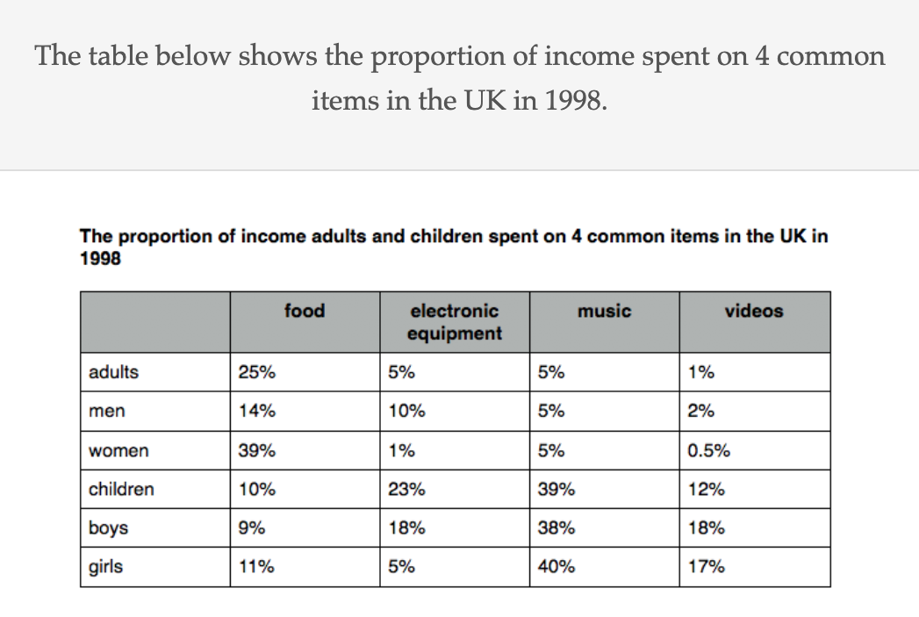
Type your answer below.
At least 150 words

